

ASSET VERIFICATION AND RECORDING TOOL KIT


Plot 31, Bukoto Street
P.O Box 7657, Kampala, Uganda
+256 (0) 39 2000216/0772525235
email: cpa@cpa.ug

www.cpa.com

August to September 2026

VERIFICATION DETAILS

NAME OF THE REGION: | CENTRAL REGION
SUB-REGION: | BUGANDA
Name of Local Government | MUBENDE MUNICIPALITY
VERIFIER PARTICULARS
Full name | KATO CHARLES
Contact/ email and Telephone | 0755790124 &  katoc560@gmail.com
Supervisor/ Sub team leader
Name | Prof: MBONIGABA DEPAUL
Contact | 0788483159
Date of submission | 06/09/2026

HEALTH CENTRES
INFORMANT INTERVIEW/DISCUSSION GUIDE (INCHARGE OR RESPONSIBLE PERSON)

Name of Health Centre: LWEMIKOMAGO

1a | Does the Facility have a record of all assets provided under UgIFT.  (Obtain a record and verify if it has the costs and numbers supplied | The list was available but didn’t have costs as well as asset numbers and expected lifetime for the equipment.
1b | If not ask how many were supplied and when.

2 | How does this facility Maintain (repair/service/replace) the assets provided under Ugift

The facility funds minor repairs using PHC funds. The facility is also aided by staff from mubende regional referral hospital to do repairs of medical equipment.

3 | Does the facility take regular record about functionality/ or breakdown of the assets provided? | Yes, the facility had a list of the items available

The facility conducts functionality checks on equipment at the end of every financial year to identify those that are faulty or broken.

4 | How has the UgIFT support helped in service delivery in the area, any issues, challenges and any recommendations for better program implementation.

The incharge expressed gratitude to UGIFT for providing equipment and structures which increased their OPD and attendance. She also complained about the short life span of some equipment such as office chairs, tables, bedside lockers and lab stool.
She recommended that Ugift should coordinate nationwide repairs for equipment in the health centers and supply an ultrasonic sound scan.

PROCEED TO VERIFICATION AFTER THIS DISCUSSION

Health centre checklist

NAME OF LG: MUBENDE MUNCIPAL COUNCIL NAME OF HEALTH FACILITY: LWEMIKOMAGO HC III

Equipment/ Item | Department | Asset Number | Item  Description | Life in Months | Tag Number (engrave no.) | Date Of Purchase | Date Placed in Service | Recoverable cost | Cost | Acc Dep Cost | Net Book Value | Ytd Deprn | Equipment status | Remarks
B.P. Machine, Digital | health |  | sinoheart, model BA-801 sionocare bp machine |  | Not engraved |  | 13/06/2025 |  |  |  |  |  | functional
 | Health |  | Sinocare bp machine, Model |  | Not engraved |  | 13/06/2025 |  |  |  |  |  | functional
B.P. Machine (Aneroid wall mounted) | health |  | BP machine (aneroid wall mounted, Navy blue in colour |  | 723/MEQUIP/1630 |  | 13/06/2025 |  |  |  |  |  | functional | 1 at OPD, 1 at the maternity
 | health |  | BP machine (aneroid wall mounted, Navy blue in colour |  | 723/MEQUIP/1631 |  | 13/06/2025 |  |  |  |  |  | functional | 1 at OPD, 1 at the maternity
Autoclave 20 Liters., Duo Operated
 | health |  | Autoclave, external heated, 20liters |  | 723/MEDQUIP/1660 |  | 13/06/2025 |  |  |  |  |  | Not functional
Bowl, Kick | Health |  | 1 stainless steel equipment with a removable bowl |  | Not engraved |  | 20/09/2025 |  |  |  |  |  | functional
Bowl Stand | Health |  | Stainless steel movable |  | Not engraved |  | 10/06/2025 |  |  |  |  |  | functional
 | health |  | Stainless steel movable |  |  |  | 10/06/2025 |  |  |  |  |  | functional
Counting chamber Neubauer- Improved
 | health |  | Rectangular shaped apparatus with droppers |  | Not engraved |  | 10/06/2025 |  |  |  |  |  | Not functional | In the store
 | Health |  | Rectangular shaped apparatus with droppers |  |  |  | 10/06/2025 |  |  |  |  |  | Not functional | In the store
Cupboard Steel, Lockable | Health
 | Health |  | 1 cupboard steel with transparent glass, lockable (grey) |  | 723/MEDQUIP/1661 |  | 10/06/2025 |  |  |  |  |  | Functional
 | Health |  | 1 cupboard steel with transparent glass, lockable (grey) |  | 723/MEDQUIP/1662 |  | 10/06/2025 |  |  |  |  |  | functional
Drip Stand
 | Health |  | 1 1Drip stand, stainless steel attached to the beds |  | 723/MEDQUIP/852 |  | 10/06/2025 |  |  |  |  |  | functional
 | Health |  | 1 Drip stand, MK-ISO, SN MM220210C01 |  | 723/MEDQUIP/853 |  | 10/06/2025 |  |  |  |  |  | functional
 | Health |  | 1 1Drip stand, MK-ISO, SN MM220210C01 |  | 723/MEDQUIP/854 |  | 10/06/2025 |  |  |  |  |  | functional
 | Health |  | 1 Drip stand, MK-ISO, SN MM220210C01 |  | 723/MEDQUIP/855 |  | 10/06/2025 |  |  |  |  |  | functional
 | Health |  | Drip stand, MK-ISO, SN MM220210C01 |  | 723/MEDQUIP/856 |  | 10/06/2025 |  |  |  |  |  | functional
 | Health |  | 1 Drip stand, MK-ISO, SN MM220210C01 |  | 723/MEDQUIP/857 |  | 10/06/2025 |  |  |  |  |  | functional
 | Health |  | 1 1Drip stand, MK-ISO, SN MM220210C01 |  | 723/MEDQUIP/858 |  | 10/06/2025 |  |  |  |  |  | functional
 | Health |  | 1 Drip stand, MK-ISO, SN MM220210C01 |  | 723/MEDQUIP/859 |  | 10/06/2025 |  |  |  |  |  | functional
ESR Stand
 | health |  | 1 ESR was available with sedimentation tubes |  | 723/MEQUIP/1641 |  | 10/06/2025 |  |  |  |  |  | functional
Examination Couch
 | Health |  | Examination couch metallic with a mattress |  | Not engraved |  | 10/06/2025 |  |  |  |  |  | functional
 | Health |  | Examination couch metallic with a mattress |  | Not engraved |  | 10/06/2025 |  |  |  |  |  | functional
Examination light,LED
 | Health |  | examination light, LED |  | Not engraved |  | 10/06/2025 |  |  |  |  |  | functional
 | health |  | examination light, LED |  | Not engraved |  | 10/06/2025 |  |  |  |  |  | functional
Glucometer |  |  |  |  |  |  |  |  |  |  |  |  |  | The strips for the glucometers were used up and the facility cannot get them from NMS
 | health |  | A Yuwell glucometer, SN: B25070000104 |  | 723/MEDQUIP/801 |  | 10/06/2025 |  |  |  |  |  | Not functional
 | health |  | A Yuwell glucometer, SN: B25070000104 |  | 723/MEDQUIP/802 |  | 10/06/2025 |  |  |  |  |  | Not functional
Haemoglobin Meter, Digital | health
 | Health |  | Haemoglobin Meter, Digital |  | 723/MEDQUIP/1664 |  | 10/06/2025 |  |  |  |  |  | Not functional
 | Health |  | Haemoglobin Meter, Digital |  | 723/MEDQUIP/1665 |  | 10/06/2025 |  |  |  |  |  | Not functional
Height Meter
 | Health |  | 1 height meter |  | 723/MEDQUIP/1 |  | 10/06/2025 |  |  |  |  |  | Functional
Instrument Trolley
 | health |  | 1 instrument trolly |  | 723/MEDQUIP/1679 |  | 10/06/2025 |  |  |  |  |  | Not Functional | Not seen, facility received one trolley
 | health |  | 1 instrument trolly |  | 723/MEDQUIP/1680 |  | 10/06/2025 |  |  |  |  |  | Functional
Microscope Binocular
 | health |  | 1 microscope binocular, |  | 723/MEQUIP/1625 |  | 10/06/2025 |  |  |  |  |  | Functional
Otoscope | health |  | 1 otoscope |  | 723/MEQUIP/1663 |  | 10/06/2025 |  |  |  |  |  | Functional
Patient Screen
 | health |  | 1 patient screen, super care model TS-19 |  | 723/MEQUIP/1626 |  | 10/06/2025 |  |  |  |  |  | Not functional
 | health |  | 1 patient screen, metallic, blue in colour, movable |  | 723/MEQUIP/1627 |  | 10/06/2025 |  |  |  |  |  | Not functional
 | health |  | 1 patient screen |  | 723/MEQUIP/1628 |  | 10/06/2025 |  |  |  |  |  | Not functional
 | health |  | 1 patient screen |  | 723/MEQUIP/1629 |  | 10/06/2025 |  |  |  |  |  | Not functional
Patient Trolley
 | Health |  | 1 patient trolley of casp |  | 723/MEDQUIP/1629 |  | 10/06/2025 |  |  |  |  |  | functional
Refrigerator, Basic
 | Health |  | 1 refrigerator basic, Hisense brand | 18 months | 723/MEQUIP/1668 |  | 10/06/2025 |  |  |  |  |  | Not functional
Stethoscope
 | Health |  | stethoscope |  | Not engraved |  | 10/06/2025 |  |  |  |  |  | Not functional
 | Health |  | stethoscope |  | Not engraved |  | 10/06/2025 |  |  |  |  |  | Not functional
 | Health |  | stethoscope |  | Not engraved |  | 10/06/2025 |  |  |  |  |  | Not functional
 | Health |  | stethoscope |  | Not engraved |  | 10/06/2025 |  |  |  |  |  | Functional
Stopwatch | Health |  | 1 stopwatch |  | 723/MEQUIP/1699 |  | 10/06/2025 |  |  |  |  |  | functional
 |  |  | 1 stopwatch |  | 723/MEQUIP/1700 |  | 10/06/2025 |  |  |  |  |  | functional
Stretcher
 | Health |  | 1 stretcher, movable |  | 723/MEDQUIP/1658 |  | 10/06/2025 |  |  |  |  |  | Functional
Stove, Gas
 | health |  | STOVE GAS |  | 723/MEQUIP/5602 |  | 10/06/2025 |  |  |  |  |  | Not Functional
Weighing Scale with Height Meter, Adult | health |  | 1 weighing scale with height measure |  | 723/MEDQUIP/1666 |  | 10/06/2025 |  |  |  |  |  | Functional
 | Health |  | 1 weighing scale with height measure |  | 723/MEDQUIP/1667 |  | 10/06/2025 |  |  |  |  |  | functional
Weighing Scale, Infant
 | Health |  | Hanging weighing scale foe infants, |  | 723/MEQUIP/1623 |  | 10/06/2025 |  |  |  |  |  | NOT FUNCTIONAL
 | Health |  | Hanging weighing scale foe infants, |  | 723/MEQUIP/1624 |  | 10/06/2025 |  |  |  |  |  | functional
Weighing Scale, Toddler | Health |  | 1 weighing scale toddler, KUANYI MODEL, BS-50 |  | 723/MEQUIP/1675 |  | 10/06/2025 |  |  |  |  |  | Functional in the maternity ward
 | Health |  | 1 weighing scale toddler, KUANYI MODEL, BS-50 |  | 723/MEQUIP/1676 |  | 10/06/2025 |  |  |  |  |  | Functional in the maternity ward
Wheelchair
Audio Visual Equipment | Health
Medical Waste Bin
 | Health |  | Stainless steel bins |  | 723/MEDQUIP/866 |  | 10/06/2025 |  |  |  |  |  | Functional
 | Health |  | Stainless steel bins |  | 723/MEDQUIP/867 |  | 10/06/2025 |  |  |  |  |  | Functional
 | Health |  | Medical waste bins |  | 723/MEDQUIP/868 |  | 10/06/2025 |  |  |  |  |  | Functional
 | Health |  | Medical waste bins |  | 723/MEDQUIP/869 |  | 10/06/2025 |  |  |  |  |  | Functional
 | Health |  | Medical waste bins |  | 723/MEDQUIP/870 |  | 10/06/2025 |  |  |  |  |  | functional
 | Health |  | Medical waste bins |  | 723/MEDQUIP/871 |  | 10/06/2025 |  |  |  |  |  | functional
Wall Clock
 | Health |  | Wall clock |  | 723/MEQUIP/1693 |  | 10/06/2025 |  |  |  |  |  | functional
 | Health |  | Wall clock |  | 723/MEQUIP/1694 |  | 10/06/2025 |  |  |  |  |  | functional
 | Health |  | Wall clock |  | 723/MEQUIP/1695 |  | 10/06/2025 |  |  |  |  |  | functional
 | Health |  | Wall clock |  | 723/MEQUIP/1696 |  | 10/06/2025 |  |  |  |  |  | Functional
Diagnostic Equipment Set for MCH
 | Health | SL304 | Full diagnostic set consisting of all equipment (full medical package) |  | NOT ENGRAVED |  | 10/06/2025 |  |  |  |  |  | NOT FUNCTIONAL
 | Health | SL304 | Full diagnostic set consisting of all equipment (full medical package) |  | NOT ENGRAVED |  | 10/06/2025 |  |  |  |  |  | NOT FUNCTIONAL
Diagnostic Equipment Set for OPD
 | Health | SL304 | 1 diagnostic equipment set |  | Not engraved |  | 10/06/2025 |  |  |  |  |  | Not functional
 | Health | SL304 | 1 diagnostic equipment set |  | Not engraved |  | 10/06/2025 |  |  |  |  |  | Not functional
Glassware Set, Laboratory, Basic
 | Health |  | 1 glass ware set` |  | Not engraved |  | 10/06/2025 |  |  |  |  |  | Functional
 | Health |  | 1 glass ware set` |  | Not engraved |  | 10/06/2025 |  |  |  |  |  | Functional
Hollow Ware Set, Treatment
Instrument Set, Dressing
 | Health | SL304 | 1 Set consists of forceps, scissors, bowls, lotion, kidney, instrument container s/s with cover. |  | Not engraved |  | 10/06/2025 |  |  |  |  |  | Functional
 | Health | SL304 | 1 Set consists of forceps, scissors, bowls, lotion, kidney, instrument container s/s with cover |  | Not engraved |  | 10/06/2025 |  |  |  |  |  | Not functional
Instrument Set, Basic ENT
 | Health | SL304 | 1 Set consists of forceps, scissors, bowls, lotion, kidney, instrument container s/s with cover. |  | Not engraved |  | 10/06/2025 |  |  |  |  |  | Functional
 | Health | SL304 | 1 Set consists of forceps, scissors, bowls, lotion, kidney, instrument container s/s with cover. |  | Not engraved |  | 10/06/2025 |  |  |  |  |  | Functional
 | Health | SL304 | 1 Set consists of forceps, scissors, bowls, lotion, kidney, instrument container s/s with cover. |  | Not engraved |  | 10/06/2025 |  |  |  |  |  | Functional
Instrument Set, Suture
Pulse Oximeter, Handheld
 | Health |  | 1 Pulse oximeter, handheld |  | 723/MEDQUIP/8838 |  | 10/06/2025 |  |  |  |  |  | Functional
 | Health |  | 1 Pulse oximeter, handheld |  | 723/MEDQUIP/839 |  | 10/06/2025 |  |  |  |  |  | Not functional
Bed, Adult Patient with Mattress
 | Health |  | Adult beds with metallic mattresses, model B11 batch no 20220542 |  | 723/MEDQUIP/1642 |  | 10/06/2025 |  |  |  |  |  | Functional
 | Health |  | Adult beds with metallic mattresses, model B11 batch no 20220542 |  | 723/MEDQUIP/1643 |  | 10/06/2025 |  |  |  |  |  | Functional
 | Health |  | Adult beds with metallic mattresses, model B11 batch no 20220542 |  | 723/MEDQUIP/1644 |  | 10/06/2025 |  |  |  |  |  | Functional
 | Health |  | Adult beds with metallic mattresses, model B11 batch no 20220542 |  | 723/MEDQUIP/1645 |  | 10/06/2025 |  |  |  |  |  | Functional
 | Health |  | Adult beds with metallic mattresses, model B11 batch no 20220542 |  | 723/MEDQUIP/1646 |  | 10/06/2025 |  |  |  |  |  | Functional
 | Health |  | Adult beds with metallic mattresses, model B11 batch no 20220542 |  | 723/MEDQUIP/1647 |  | 10/06/2025 |  |  |  |  |  | Functional
 | Health |  | Adult beds with metallic mattresses, model B11 batch no 20220542 |  | 723/MEDQUIP/1648 |  | 10/06/2025 |  |  |  |  |  | Functional
 | Health |  | Adult beds with metallic mattresses, model B11 batch no 20220542 |  | 723/MEDQUIP/1649 |  | 10/06/2025 |  |  |  |  |  | Functional
 | Health |  | Adult beds with metallic mattresses, model B11 batch no 20220542 |  | 723/MEDQUIP/1650 |  | 10/06/2025 |  |  |  |  |  | Functional
 | Health |  | Adult beds with metallic mattresses, model B11 batch no 20220542 |  | 723/MEDQUIP/1651 |  | 10/06/2025 |  |  |  |  |  | functional
Bed, Pediatric Patient, With Mattress
 | Health |  | Pediatric beds with metallic mattresses |  | 723/MEDQUIP/1652 |  | 10/06/2025 |  |  |  |  |  | Functional
 | Health |  | pediatrics beds with mattresses metallic |  | 723/MEDQUIP/1653 |  | 10/06/2025 |  |  |  |  |  | Functional
 | Health |  | pediatrics beds with mattresses metallic |  | 723/MEDQUIP/1654 |  | 10/06/2025 |  |  |  |  |  | Functional
 | Health |  | pediatric beds with mattresses metallic |  | 723/MEDQUIP/1655 |  | 10/06/2025 |  |  |  |  |  | Functional
 | Health |  | Pediatric beds with metallic mattresses |  | 723/MEDQUIP/1656 |  | 10/06/2025 |  |  |  |  |  | Functional
Bedside Locker
 | Health |  | Metallic bedside lockers, steel |  | 723/MEDQUIP/840 |  | 10/06/2025 |  |  |  |  |  | Functional
 | health |  | Metallic bedside lockers, steel |  | 723/MEDQUIP/841 |  | 10/06/2025 |  |  |  |  |  | functional
 | Health |  | Metallic bedside lockers, steel |  | 723/MEDQUIP/842 |  | 10/06/2025 |  |  |  |  |  | Functional
 | health |  | Metallic bedside lockers, steel |  | 723/MEDQUIP/843 |  | 10/06/2025 |  |  |  |  |  | functional
 | Health |  | Metallic bedside lockers, steel |  | 723/MEDQUIP/844 |  | 10/06/2025 |  |  |  |  |  | Functional
 | health |  | Metallic bedside lockers, steel |  | 723/MEDQUIP/845 |  | 10/06/2025 |  |  |  |  |  | functional
 | Health |  | Metallic bedside lockers, steel |  | 723/MEDQUIP/846 |  | 10/06/2025 |  |  |  |  |  | Functional
 | health |  | Metallic bedside lockers, steel |  | 723/MEDQUIP/847 |  | 10/06/2025 |  |  |  |  |  | functional
 | Health |  | Metallic bedside lockers, steel |  | 723/MEDQUIP/848 |  | 10/06/2025 |  |  |  |  |  | Functional
 | health |  | Metallic bedside lockers, steel |  | 723/MEDQUIP/849 |  | 10/06/2025 |  |  |  |  |  | functional
Cupboard, Instrument
 |  |  | 1 cupboard steel lockable |  | Not engraved |  | 10/06/2025 |  |  |  |  |  | functional
Delivery Bed, Hydraulic Manual
 | health |  | 1 Delivery bed manual hydraulic |  | 723/MEDQUIP/1657 |  | 10/06/2025 |  |  |  |  |  | functional
Oxygen Therapy Apparatus, Minimum 45L cylinder
 |  |  | 1 Oxygen cylinders of 49,8L 2, oxygen regulators (2), humidifier bottles (2) |  | 723/MEDQUIP/850 |  | 10/06/2025 |  |  |  |  |  | Not functional
 | Health |  | 1 Oxygen cylinders of 49,8L 2, oxygen regulators (2), humidifier bottles (2) |  | 723/MEDQUIP/851 |  | 10/06/2025 |  |  |  |  |  | Not functional
Resuscitator Manual, Infant, with all Mask sizes | Health |  | 1 resuscitator manual |  | Not engraved |  | 10/06/2025 |  |  |  |  |  | Not functional
 | Health |  | 1 resuscitator manual |  | Not engraved |  | 10/06/2025 |  |  |  |  |  | Not functional
Resuscitator Manual, Adult, with all mask sizes | Health |  | 1 resuscitator manual, adult |  | Not engraved |  | 10/06/2025 |  |  |  |  |  | Not functional
 | Health |  | 1 resuscitator manual, adult |  | Not engraved |  | 10/06/2025 |  |  |  |  |  | Not functional
Suction Apparatus, (Electric) | Health |  | 1 suction apparatus, electric |  | 723/MEQUIP/1634 |  | 10/06/2025 |  |  |  |  |  | Not functional
 | Health |  | 1 suction apparatus, electric |  | 723/MEQUIP/1635 |  | 10/06/2025 |  |  |  |  |  | Not functional
Nebulizer, Ultrasonic
 | Health |  | 1 nebulizer ultrasonic |  | 723/MEQUIP/1640 |  | 10/06/2025 |  |  |  |  |  | Not functional
Oxygen Concentrator, Duo Flow
 | Health |  | 1 Oxygen concentrator |  | 723/MEQUIP/1636 |  | 10/06/2025 |  |  |  |  |  | functional
 | Health |  | 1 Oxygen concentrator |  | 723/MEQUIP/1637 |  | 10/06/2025 |  |  |  |  |  | functional
 | Health |  | 1Oxygen concentrator |  | 723/MEQUIP/1638 |  | 10/06/2025 |  |  |  |  |  | functional
 | Health |  | 1Oxygen concentrator |  | 723/MEQUIP/1639 |  | 10/06/2025 |  |  |  |  |  | functional
Bench
 | Health |  | 1 metallic vanished bench |  | 723/FUR/1288 |  | 10/06/2025 |  |  |  |  |  | functional
 | Health |  | 1 metallic vanished bench |  | 723/FUR/1289 |  | 10/06/2025 |  |  |  |  |  | functional
 | Health |  | 1 metallic vanished bench |  | 723/FUR/1290 |  | 10/06/2025 |  |  |  |  |  | functional
 | Health |  | 1 metallic vanished bench |  | 723/FUR/1291 |  | 10/06/2025 |  |  |  |  |  | functional
Disinfection Buckets
 | Health |  | 1 disinfection bucket |  | 723/MEDQUIP/860 |  | 10/06/2025 |  |  |  |  |  | functional
 | Health |  | 1 disinfection bucket |  | 723/MEDQUIP/861 |  | 10/06/2025 |  |  |  |  |  | functional
 | Health |  | 1 disinfection bucket |  | 723/MEDQUIP/862 |  | 10/06/2025 |  |  |  |  |  | functional
 | Health |  | 1 disinfection bucket |  | 723/MEDQUIP/863 |  | 10/06/2025 |  |  |  |  |  | functional
 | Health |  | 1 disinfection bucket |  | 723/MEDQUIP/864 |  | 10/06/2025 |  |  |  |  |  | functional
 | Health |  | 1 disinfection bucket |  | 723/MEDQUIP/865 |  | 10/06/2025 |  |  |  |  |  | functional
Baby Cot
 | Health |  | 1 baby cot |  | Not engraved |  | 10/06/2025 |  |  |  |  |  | functional
 | Health |  | 1 baby cot |  | Not engraved |  | 10/06/2025 |  |  |  |  |  | functional
 | Health |  | 1 baby cot |  | Not engraved |  | 10/06/2025 |  |  |  |  |  | Not functional
 | Health |  | 1 baby cot |  | Not engraved |  | 10/06/2025 |  |  |  |  |  | Not functional
 | Health |  | 1 baby cot |  | Not engraved |  | 10/06/2025 |  |  |  |  |  | Not functional
Diagnostic Equipment Set for Ward | Health |  |  |  |  |  | 10/06/2025
 | health |  | 1 Set consists of:  Depressor, tongue, metal, hammer, percussion, reflex test, solid rubber head, ophthalmoscope, aneroid cuffs, stethoscope, tape, measure, cloth, thermometers, tuning forks, proctoscope, and syringes |  | Not engraved |  | 10/06/2025 |  |  |  |  |  | Functional
 | health |  | 1 Set consists of:  Depressor, tongue, metal, hammer, percussion, reflex test, solid rubber head, ophthalmoscope, aneroid cuffs, stethoscope, tape, measure, cloth, thermometers, tuning forks, proctoscope, and syringes |  | Not engraved |  | 10/06/2025 |  |  |  |  |  | Not Functional
 | health |  | 1 Set consists of:  Depressor, tongue, metal, hammer, percussion, reflex test, solid rubber head, ophthalmoscope, aneroid cuffs, stethoscope, tape, measure, cloth, thermometers, tuning forks, proctoscope, and syringes |  | Not engraved |  | 10/06/2025 |  |  |  |  |  | Not Functional
Hollow Ware Set, Ward |  |  |  |  |  |  | 10/06/2025
 | Health |  | 1 hollow ware set consisting of a bed pan s/s with lid, bowl, urinal, lotions, forceps, instrument trays, jug measuring 1 litre, and kidney dishes |  | Not engraved |  | 10/06/2025 |  |  |  |  |  | Not functional
 | Health |  | 1 hollow ware set consisting of a bed pan s/s with lid, bowl, urinal, lotions, forceps, instrument trays, jug measuring 1 litre, and kidney dishes |  | Not engraved |  | 10/06/2025 |  |  |  |  |  | Not functional
 | Health |  | 1 hollow ware set consisting of a bed pan s/s with lid, bowl, urinal, lotions, forceps, instrument trays, jug measuring 1 litre, and kidney dishes |  | Not engraved |  | 10/06/2025 |  |  |  |  |  | Not functional
Instrument Set, Delivery | Health |  | 1 set consisting of forceps, sponge holding, needle holder, scissors, speculum, bowls, kidney dish, and instrument container |  | Not engraved |  | 10/06/2025 |  |  |  |  |  | functional
 | Health |  | 1 set consisting of forceps, sponge holding, needle holder, scissors, speculum, bowls, kidney dish, and instrument container |  | Not engraved |  | 10/06/2025 |  |  |  |  |  | functional
 | Health |  | 1 set consisting of forceps, sponge holding, needle holder, scissors, speculum, bowls, kidney dish, and instrument container |  | Not engraved |  | 10/06/2025 |  |  |  |  |  | functional
Instrument Set, Stitch Removing
 | Health |  | 1 set, stitch removing consisting of forceps, sponge holding, scissors, bowls, lotion, and instrument containers |  | Not engraved |  | 10/06/2025 |  |  |  |  |  | functional
 | Health |  | 1 set, stitch removing consisting of forceps, sponge holding, scissors, bowls, lotion, and instrument containers |  | Not engraved |  | 10/06/2025 |  |  |  |  |  | functional
 | Health |  | 1 set, stitch removing consisting of forceps, sponge holding, scissors, bowls, lotion, and instrument containers |  | Not engraved |  | 10/06/2025 |  |  |  |  |  | functional
MVA Kit | Health |  | 1 MVA kit consisting of MVA Kit (double valve) forceps, sponge holding, manual valve aspirator, syringe aspirator 60CC, Karman cannulas with adaptor, speculum bowls, lotion |  | Not engraved |  | 10/06/2025 |  |  |  |  |  | functional
 | Health |  | 1 MVA kit consisting of MVA Kit (double valve) forceps, sponge holding, manual valve aspirator, syringe aspirator 60CC, Karman cannulas with adaptor, speculum bowls, lotion |  | Not engraved |  | 10/06/2025 |  |  |  |  |  | Not functional
 | Health |  | 1 MVA kit consisting of MVA Kit (double valve) forceps, sponge holding, manual valve aspirator, syringe aspirator 60CC, Karman cannulas with adaptor, speculum bowls, lotion |  | Not engraved |  | 10/06/2025 |  |  |  |  |  | functional
 | Health |  | 1 MVA kit consisting of MVA Kit (double valve) forceps, sponge holding, manual valve aspirator, syringe aspirator 60CC, Karman cannulas with adaptor, speculum bowls, lotion |  | Not engraved |  | 10/06/2025 |  |  |  |  |  | Not functional
Stool, Laboratory
 | Health |  | 1 movable metallic stool |  | Not engraved |  | 10/06/2025 |  |  |  |  |  | functional
Penguin Sucker
 | Health |  | 1 penguin |  | Not engraved |  | 10/06/2025 |  |  |  |  |  | Functional
 | Health |  | 1 penguin |  | Not engraved |  | 10/06/2025 |  |  |  |  |  | Functional
 | Health |  | 1 penguin |  | Not engraved |  | 10/06/2025 |  |  |  |  |  | Functional
Fetoscope, Dopplar
 | Health |  | 1 fetoscope |  | 723/MEQUIP/1666 |  | 10/06/2025 |  |  |  |  |  | functional
Bubble CPAP
 | Health |  | 1 bubble CPAP |  | 723/MEQUIP/1632 |  | 10/06/2025 |  |  |  |  |  | Not functional
 | Health |  | 1 bubble CPAP |  | 723/MEQUIP/1633 |  | 10/06/2025 |  |  |  |  |  | Not functional
Centrifuge (Electric)
 | Health |  | 1 Centrifuge, new |  | 723/MEQUIP/1621 |  | 10/06/2025 |  |  |  |  |  | Functional
 | Health |  | 1 Centrifuge, new |  | 723/MEQUIP/1622 |  | 10/06/2025 |  |  |  |  |  | Functional
Kangaroo Mother Care Chair
 | Health |  | 1 kangaroo mother care chair, brown colour |  | 723/MEQUIP/1672 |  | 10/06/2025 |  |  |  |  |  | Not functional
Radiant Infant Warmer
Haemoglobin Meter, Sahli
 | Health |  | 1 haemoglobin meter |  | Not engraved |  | 10/06/2025 |  |  |  |  |  | Not functional
 | Health |  | 1 haemoglobin meter |  | Not engraved |  | 10/06/2025 |  |  |  |  |  | Not functional
Delivery Bed
 | Health |  | 1 Delivery bed |  | Not engraved |  | 10/06/2025 |  |  |  |  |  | Functional
Examination light
 | Health |  | 1 examination light |  | 723/MEQUIP/1677 |  | 10/06/2025 |  |  |  |  |  | functional
 | Health |  | 1 examination light |  | 723/MEQUIP/1678 |  | 10/06/2025 |  |  |  |  |  | functional
Instrument set, ENT Basic for HCIII
 | Health |  | 1 instrument set , ENT Basic |  | Not engraved |  | 10/06/2025 |  |  |  |  |  | functional
 | Health |  | 1 instrument set , ENT Basic |  | Not engraved |  | 10/06/2025 |  |  |  |  |  | functional
 | Health |  | 1 instrument set , ENT Basic |  | Not engraved |  | 10/06/2025 |  |  |  |  |  | functional
Bag Valve mask (Ambu Bag), Neonatal | Health |  | 1 ambu bag |  | Not engraved |  | 10/06/2025 |  |  |  |  |  | Not functional
Incubator
Office Chair
 | health |  | Office chair, leather cushioned |  | Not engraved |  | 10/06/2025 |  |  |  |  |  | Functional
 | health |  | Office chair, leather cushioned |  | Not engraved |  | 10/06/2025 |  |  |  |  |  | Functional
 | health |  | Office chair, leather cushioned |  | Not engraved |  | 10/06/2025 |  |  |  |  |  | Functional
 | health |  | Office chair, leather cushioned |  | Not engraved |  | 10/06/2025 |  |  |  |  |  | Functional
 | health |  | Office chair, leather cushioned |  | Not engraved |  | 10/06/2025 |  |  |  |  |  | Functional
 | health |  | Office chair, leather cushioned |  | Not engraved |  | 10/06/2025 |  |  |  |  |  | Functional
 | Health |  | Office chair, leather cushioned |  | Not engraved |  | 10/06/2025 |  |  |  |  |  | functional
Desk | Health |  | Table metallic frame of wooden top |  | 723/FUR/814 |  | 10/06/2025 |  |  |  |  |  | functional
 | Health |  | Table metallic frame of wooden top |  | 723/FUR/815 |  | 10/06/2025 |  |  |  |  |  | functional
 | Health |  | Table metallic frame of wooden top |  | 723/FUR/816 |  | 10/06/2025 |  |  |  |  |  | functional
 | Health |  | Table metallic frame of wooden top |  | 723/FUR/817 |  | 10/06/2025 |  |  |  |  |  | functional
Filing Cabinet |  |  |  |  |  |  | 10/06/2025
 | Health |  | Filling cabinet |  | 723/MEDQUIP/1671 |  | 10/06/2025 |  |  |  |  |  | Functional
Non-Residential Buildings | Health |  | MATERNITY BUILDING, with a placenta pit |  | Not engraved |  | 10/06/2025 |  |  |  |  |  | functional
 | Health |  | 1 six-stance lined pit latrine |  | Not engraved |  | 10/06/2025 |  |  |  |  |  | functional
 | Health |  | 1 fenced solar house with solar panels and batteries |  | Not engraved |  | 10/06/2025 |  |  |  |  |  | functional
Residential Buildings

The table below illustrates some physical status of the verified assets with photographic evidence.
Table 1: Physical verification photos

SIGNPOST
COMMISSIONING PLAQUE | THE BUILDING HAD NO COMISSIONING PLAQUE
MATERNITY BUIL

DING WITH A WASTE PIT AND A PLACENTA PIT

MATERNITY BUIL  DING WITH A WASTE PIT AND A PLACENTA PIT | 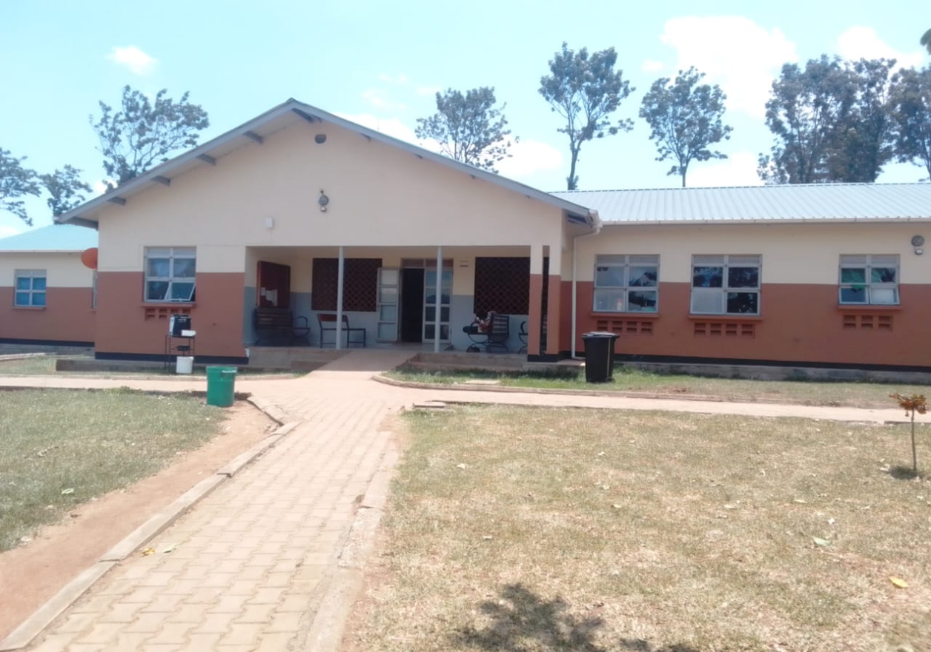
Refrigerator | 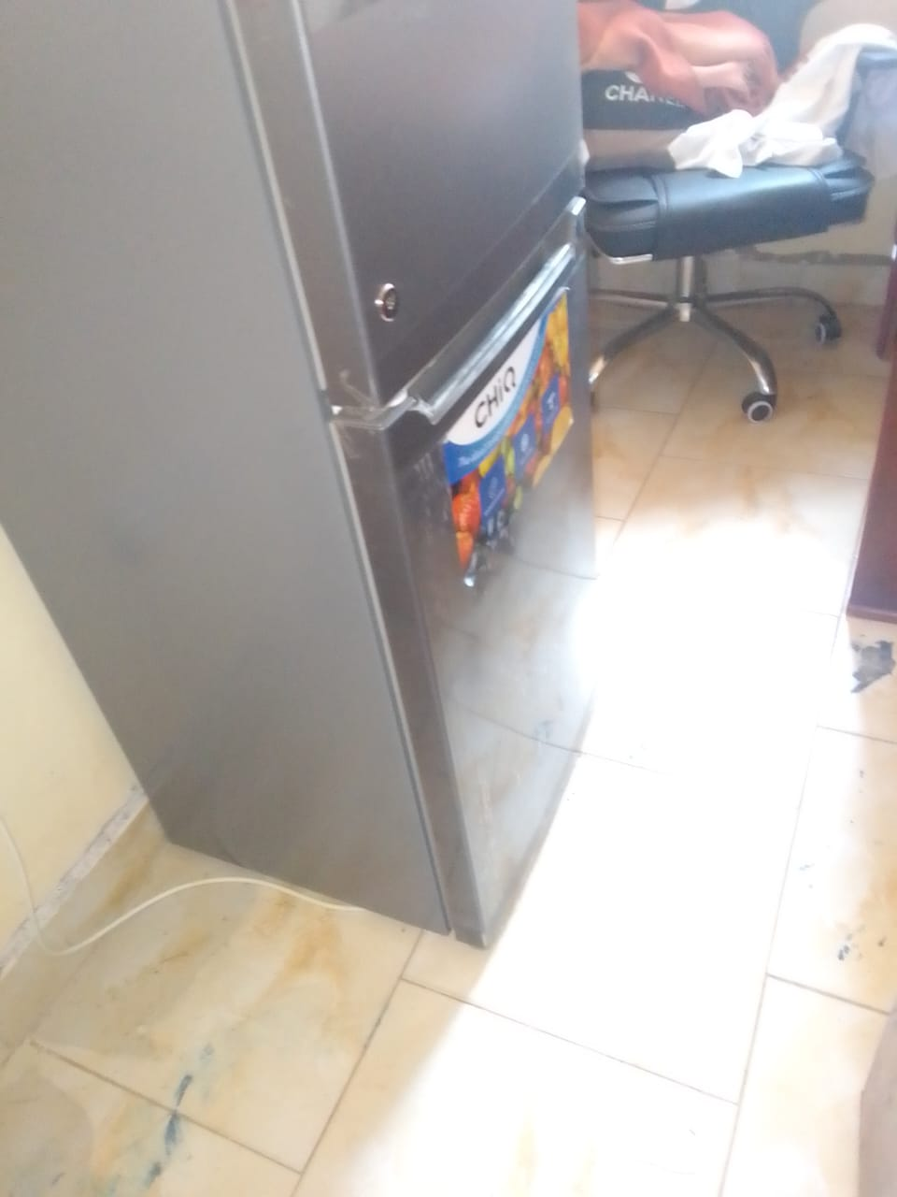
Sample of BP machine, aneroid | 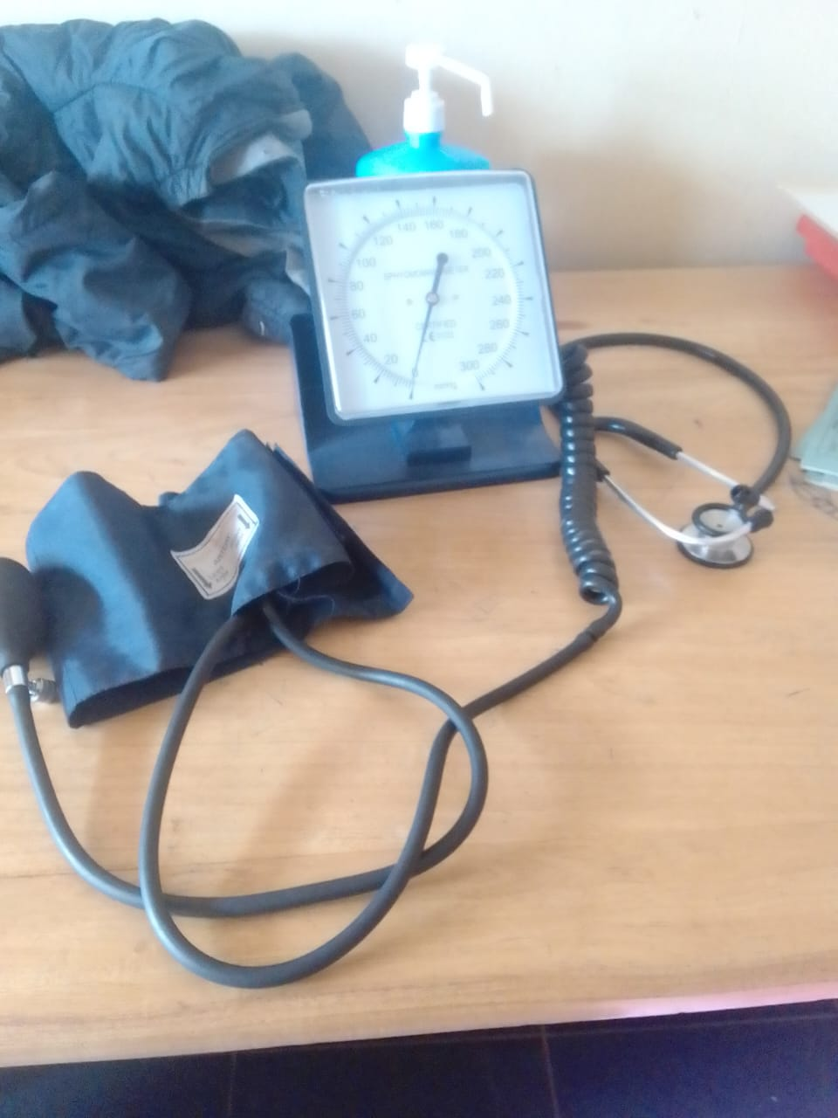
Spoilt bedside lockers | 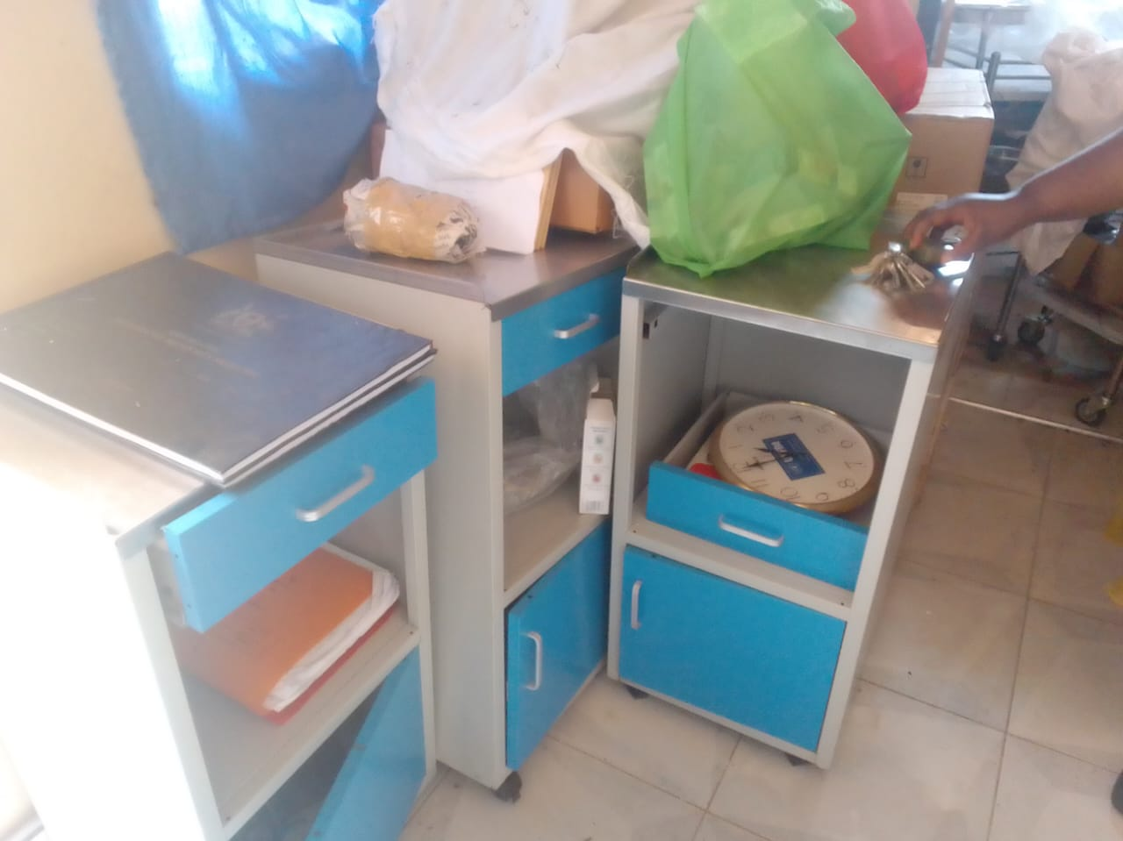
Examination couch, and patient screen | 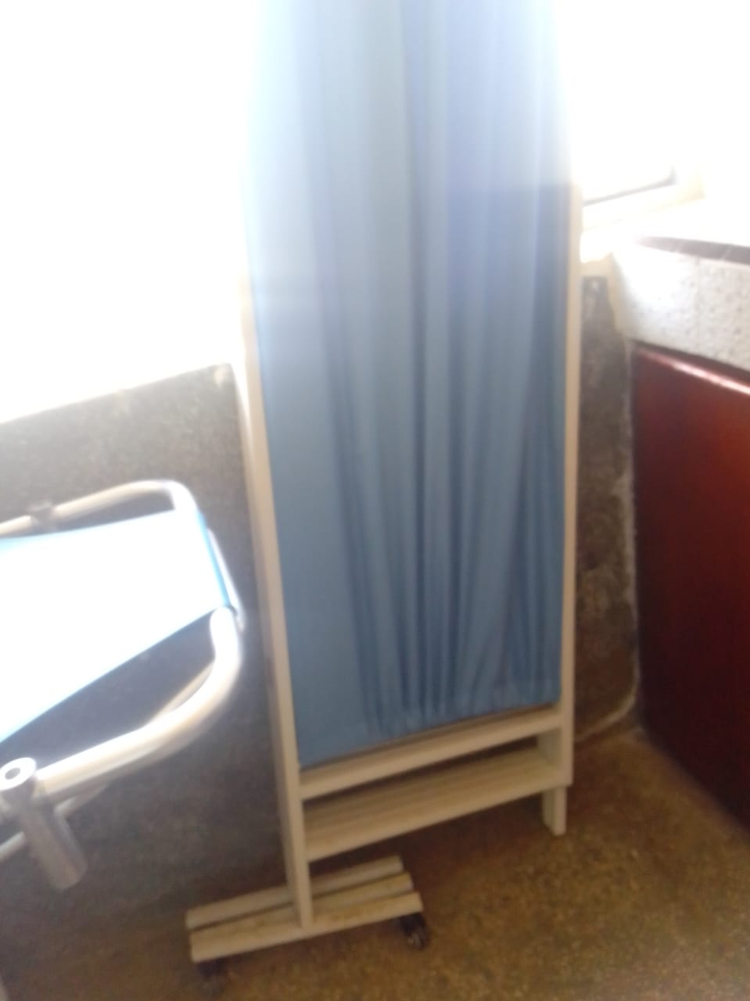
Delivery bed, hydraulic | 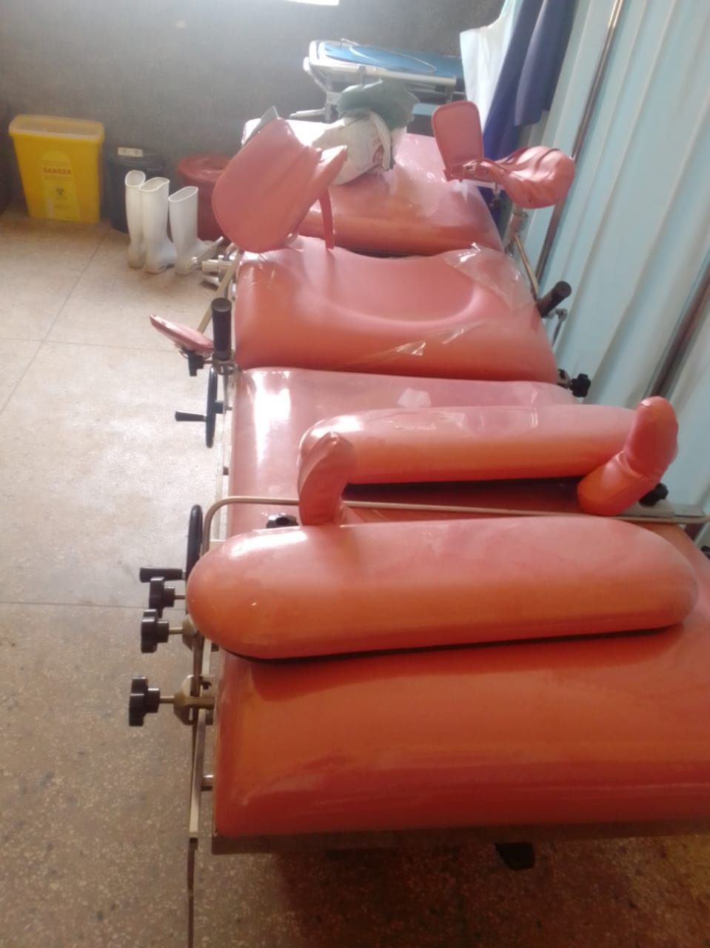
Delivery sets, and instrument trolley | 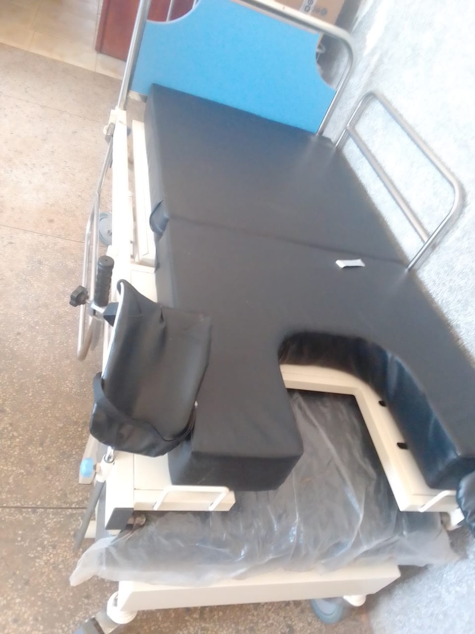
ESR STAND, engraved | 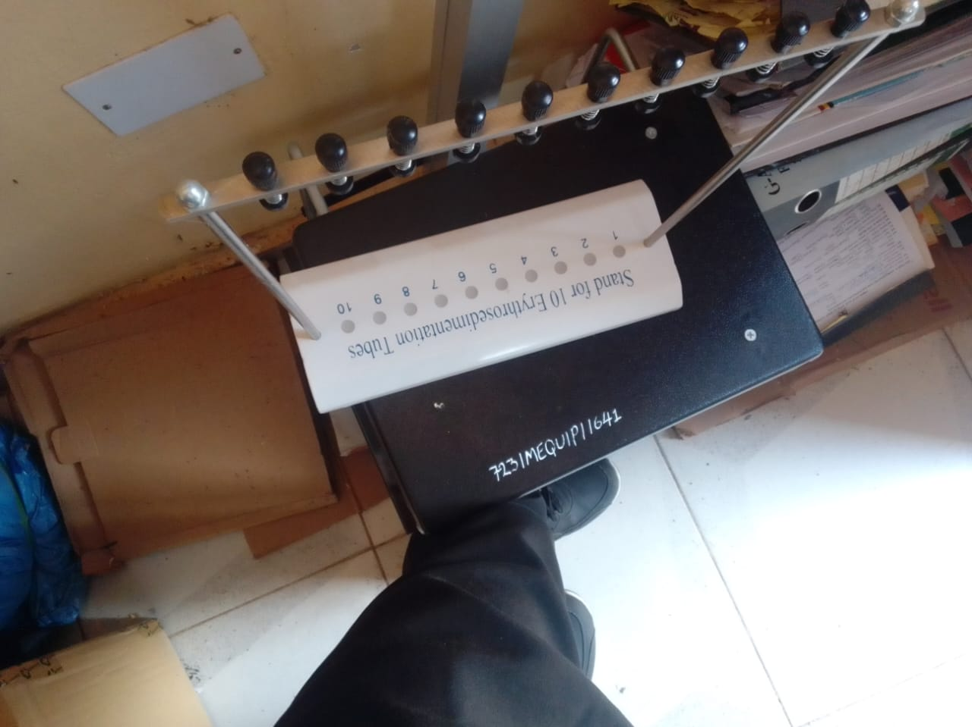
Oxygen therapy apparatus | 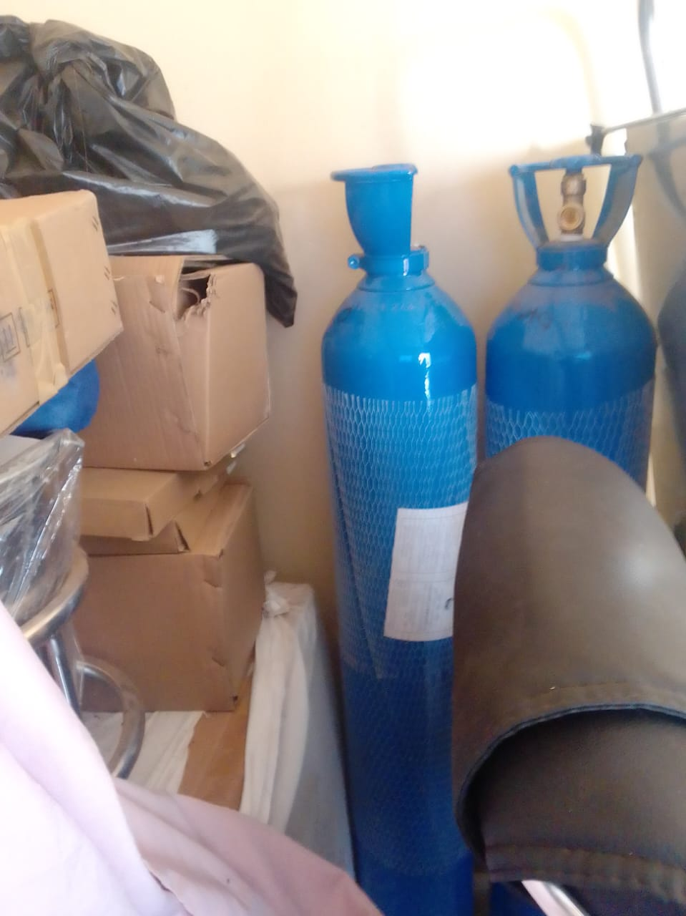
Tables, that are engraved | 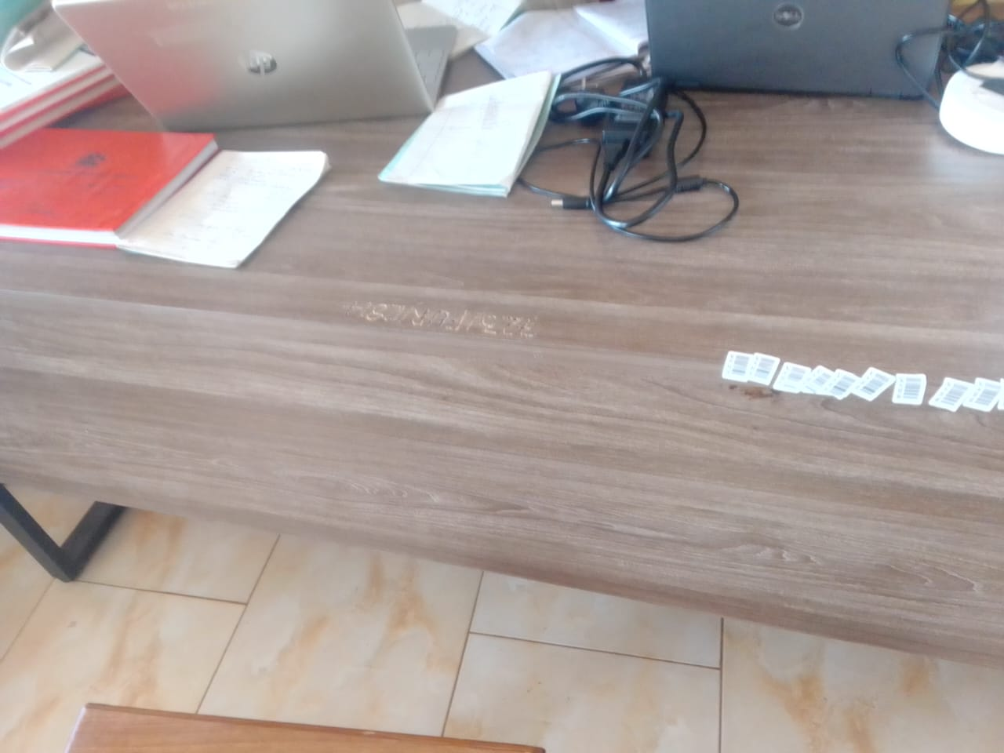
Sample of the benches that are engraved | 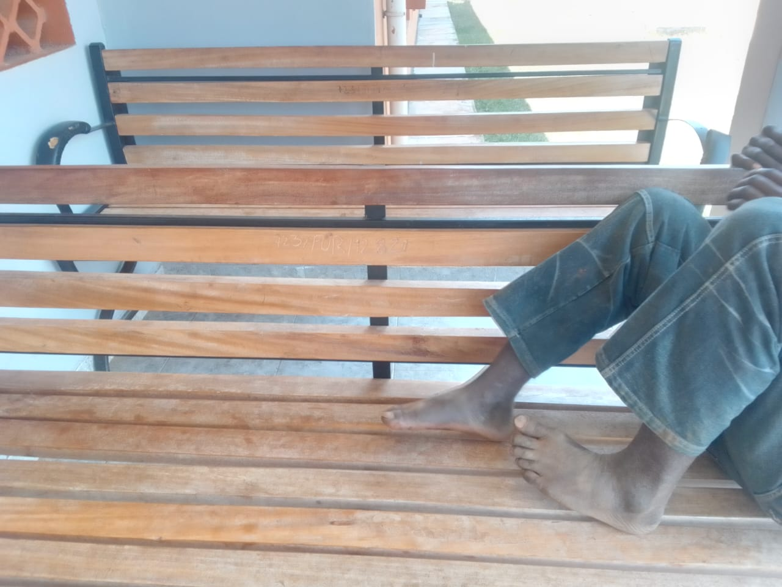
Cupboard with glass. | 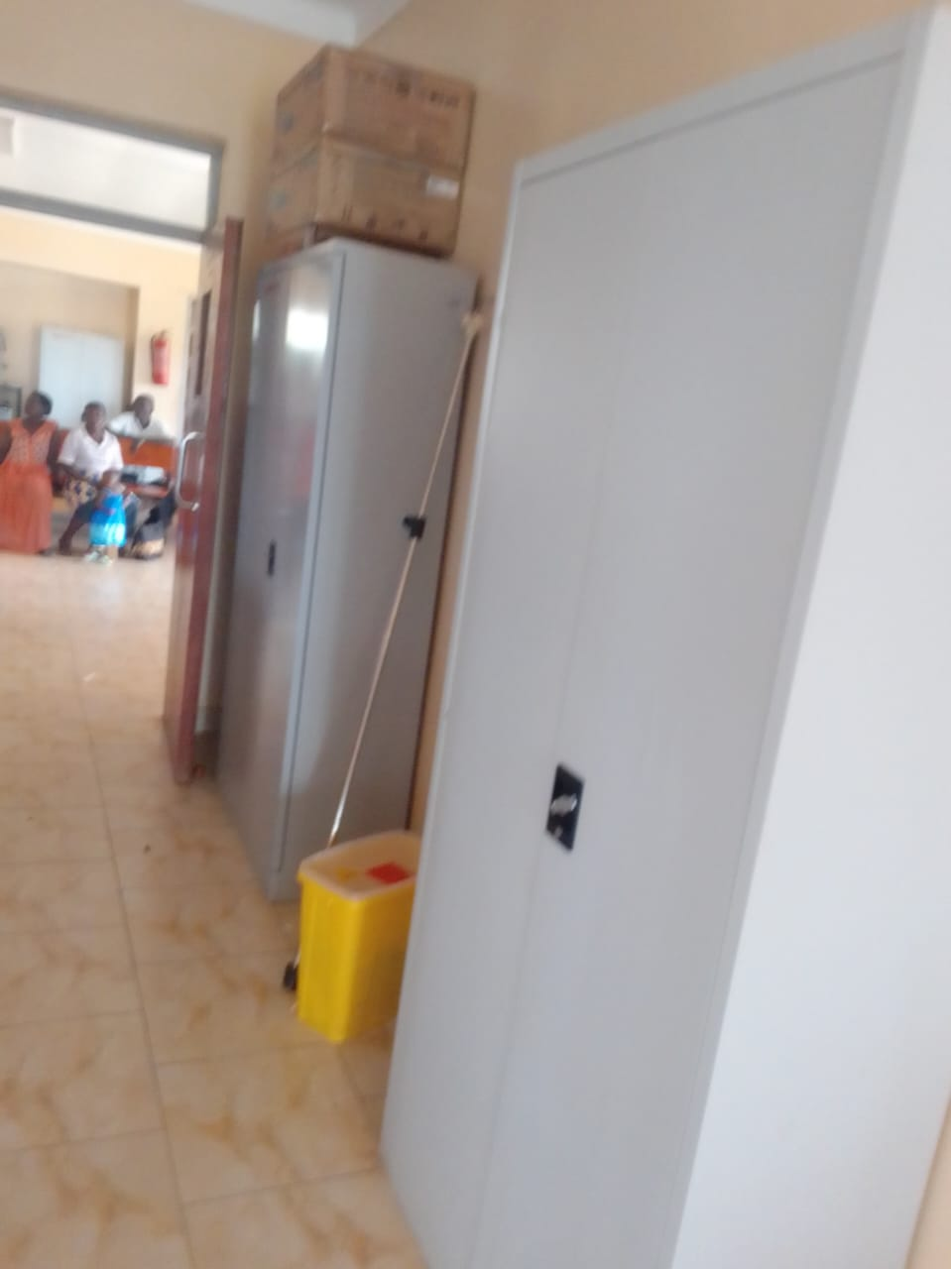
Weighing scale toddler, and other equipment packed in the store | 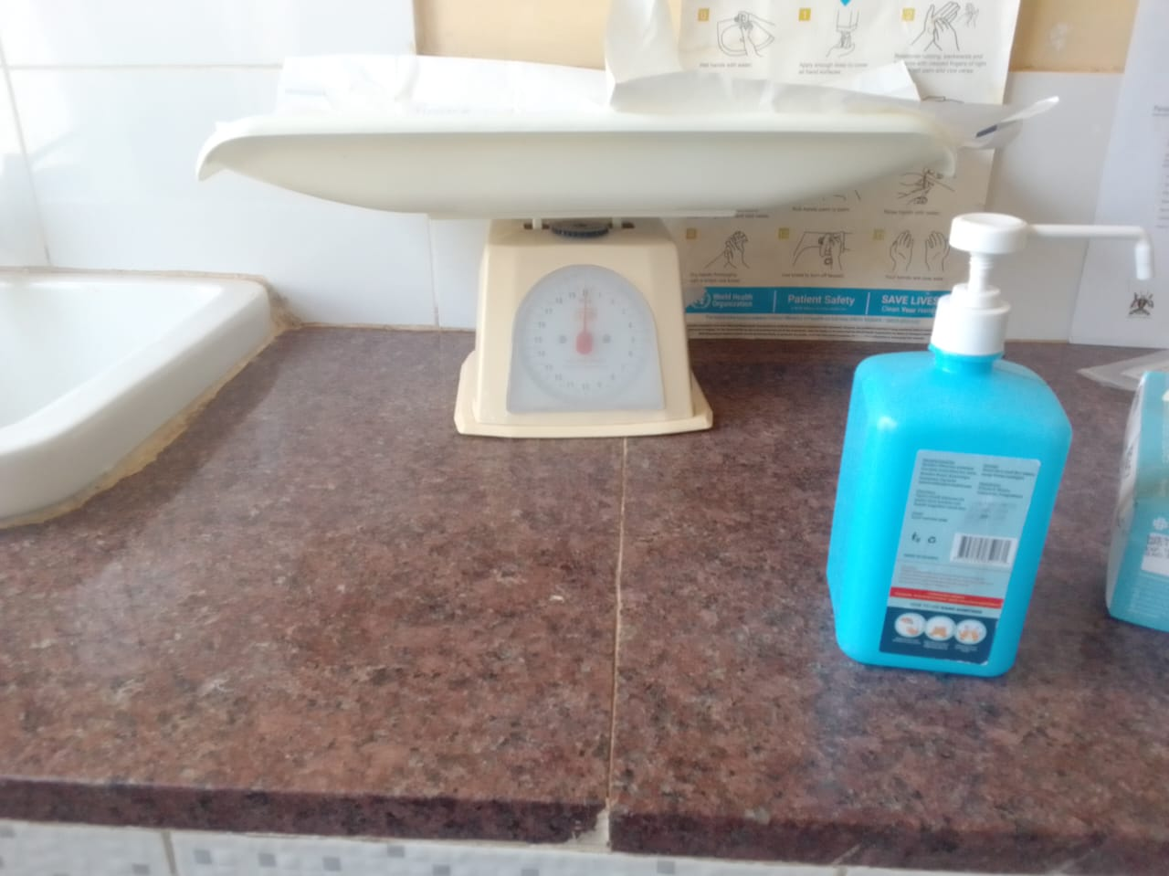
Sample of wighing scale, adult with a height meter | 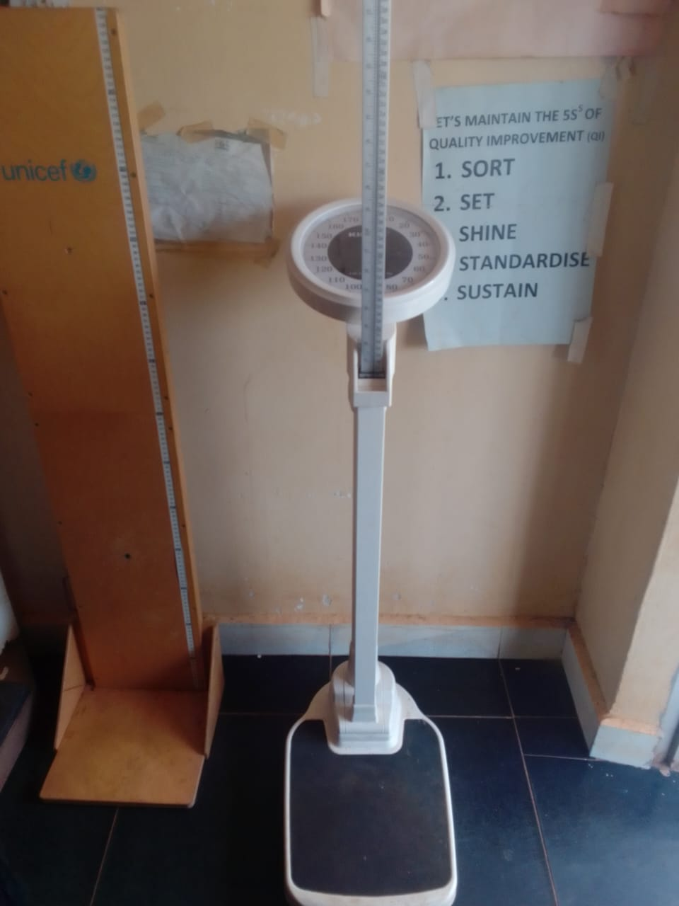
Spoilt office chairs in the store | 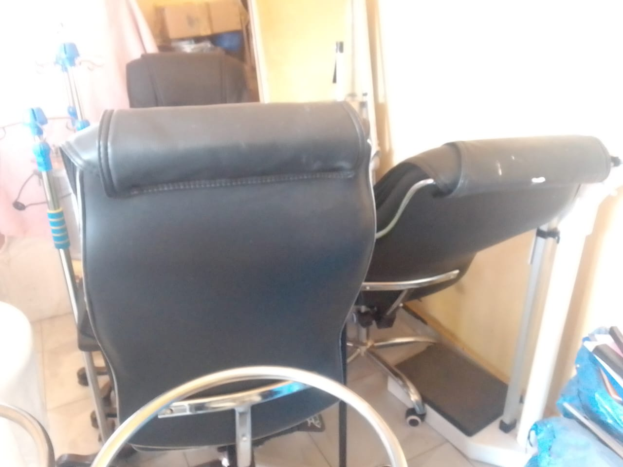
Sample of patient screens in the store, and drip stands | 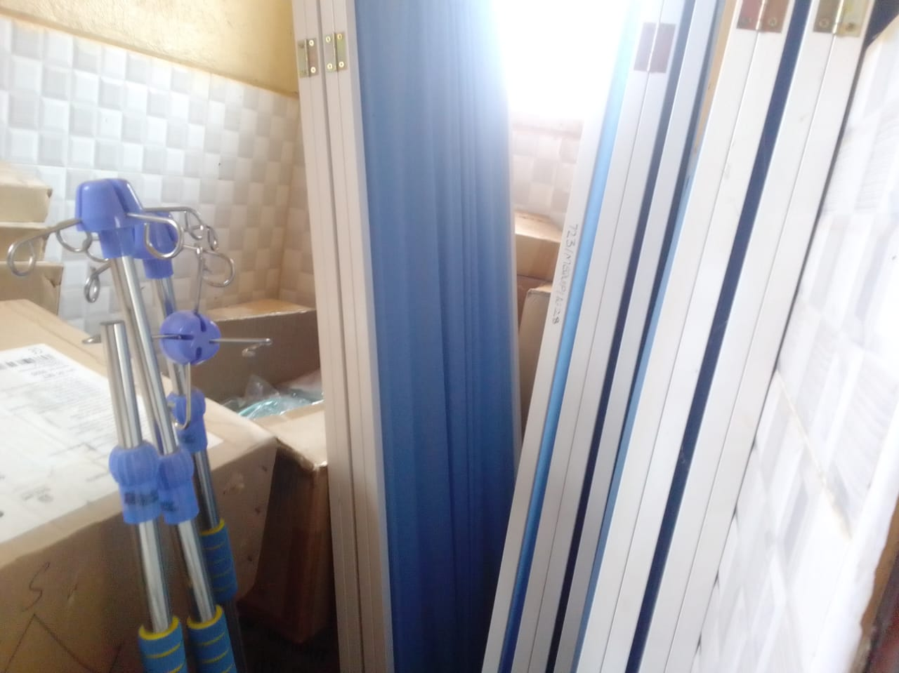
Sample autoclave | 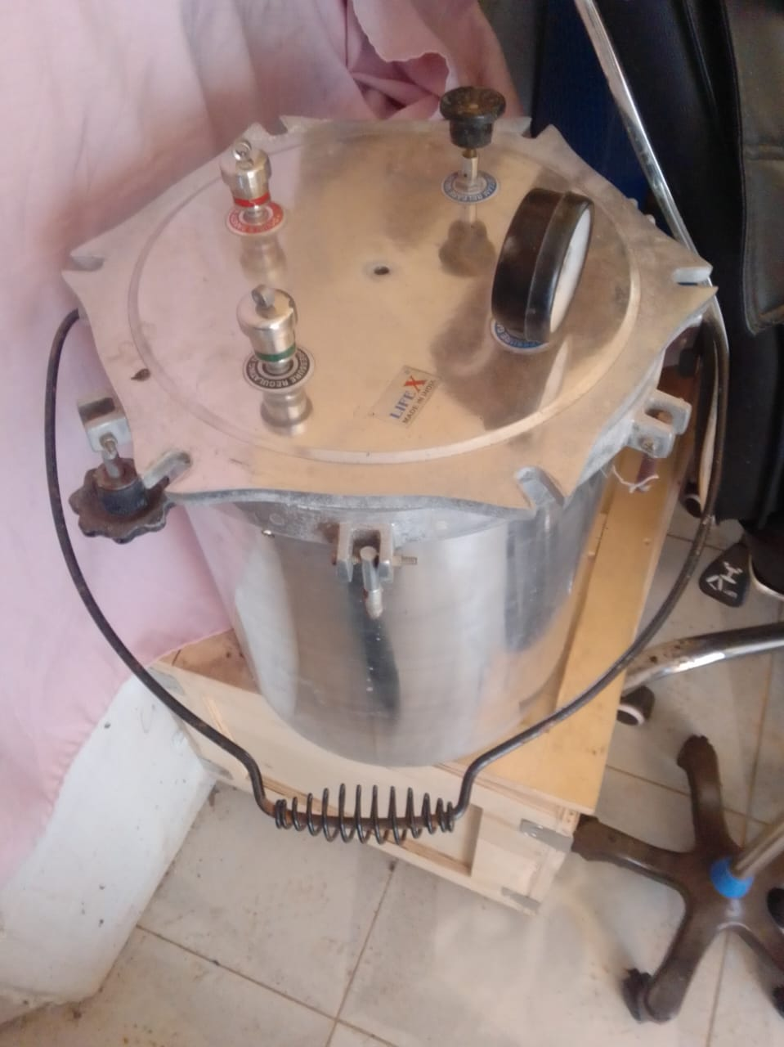
Sample of Stretcher, engraved | 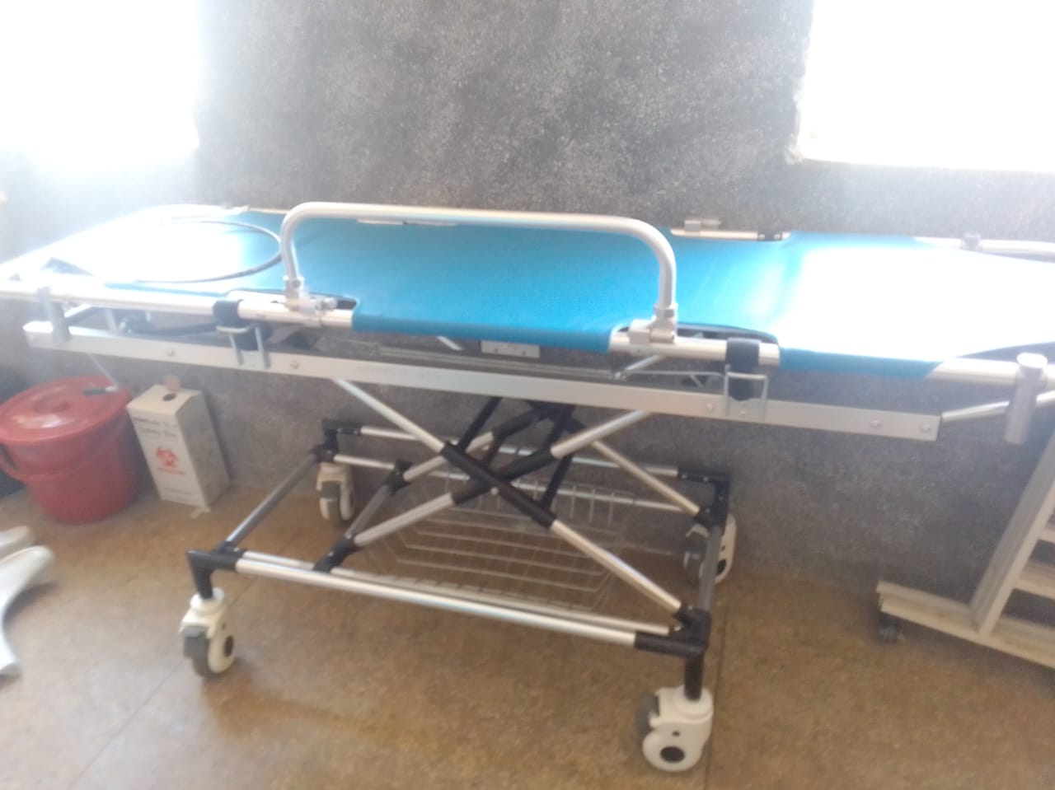
Sample of adult patient beds with drip stands | 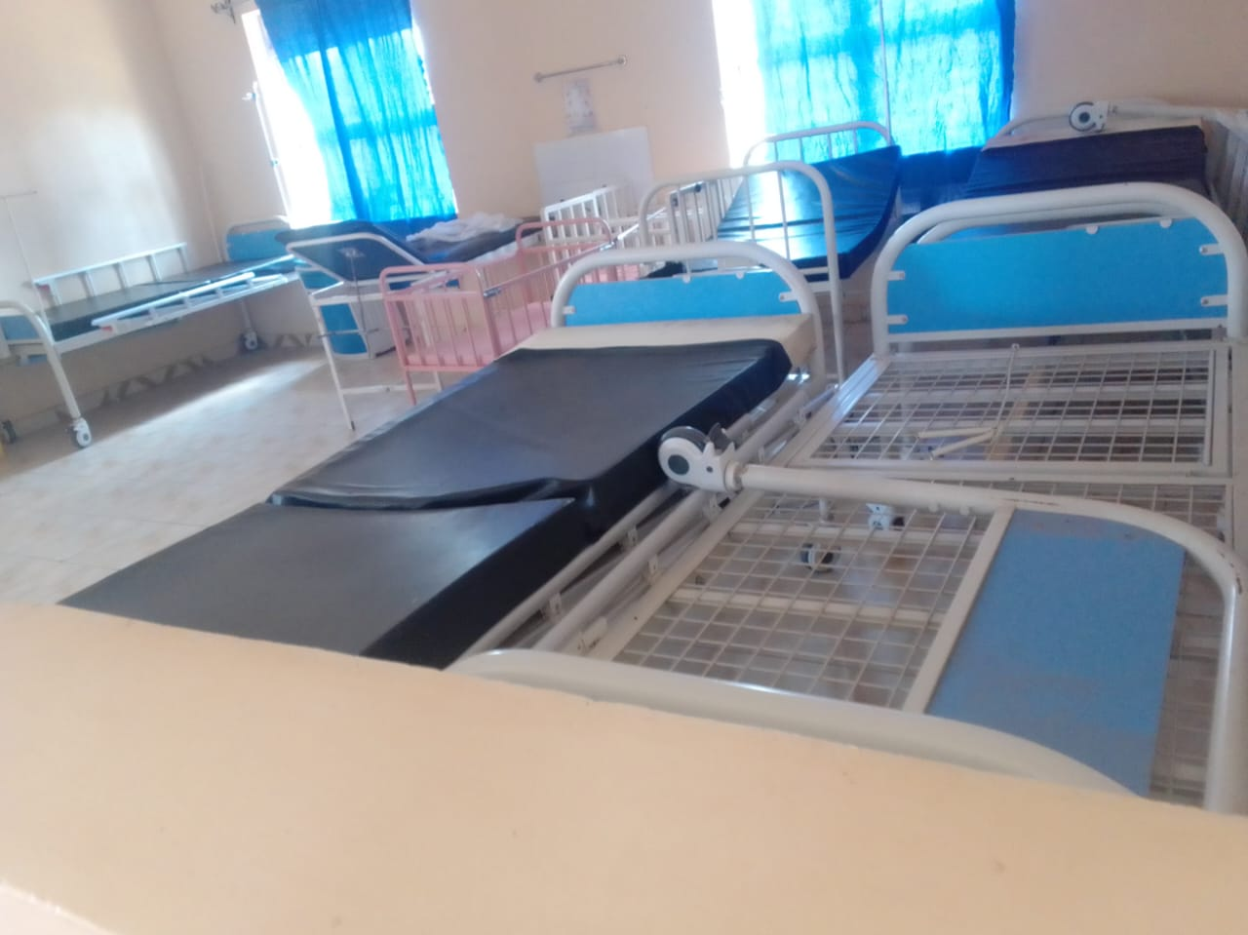
Sample of a drip stand, engraved | 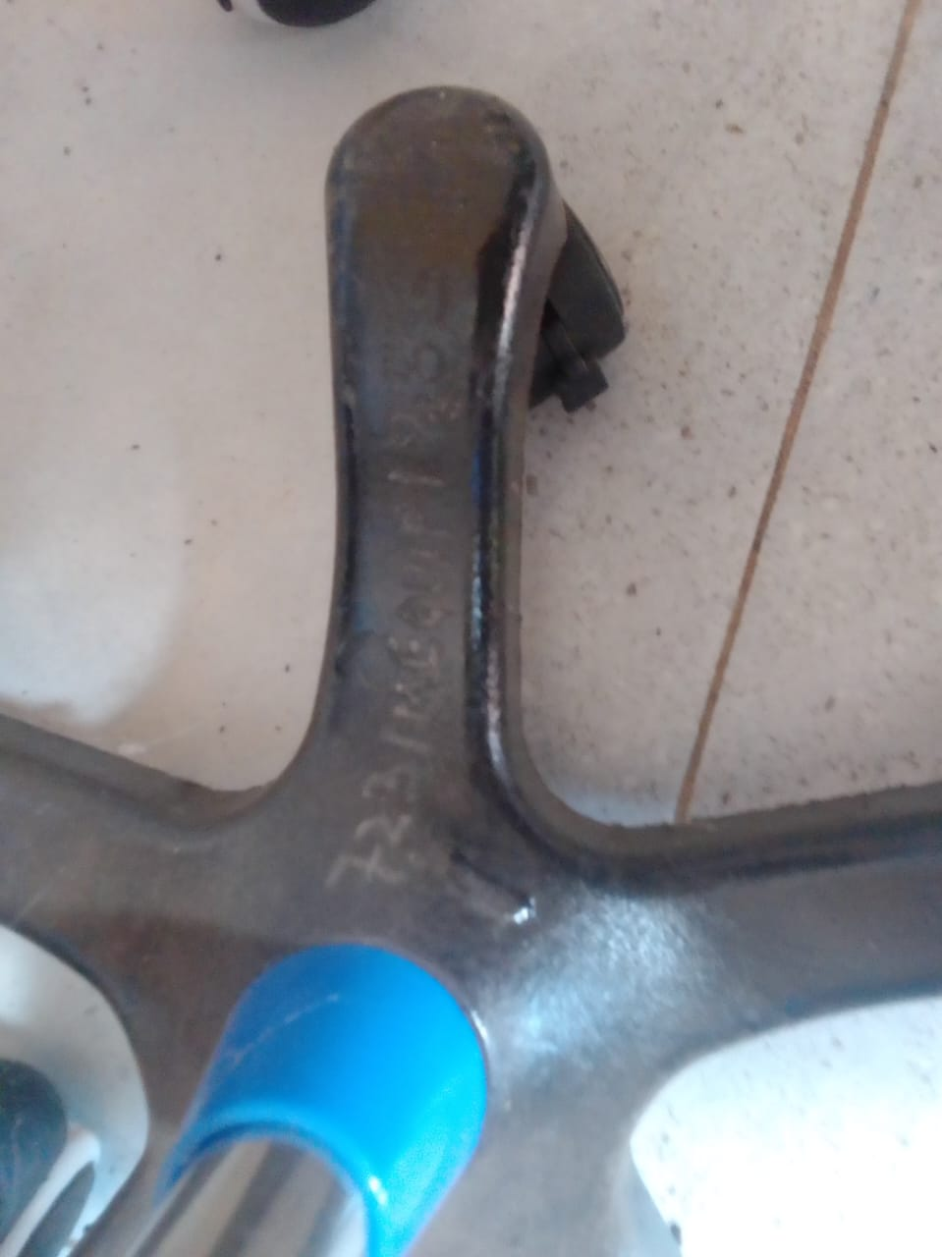
Patients screens engraved | 